Part 1
Method
We want to determine how Hooke’s Law applies for certain objects in the lab, including identifying their linear and non-linear regimes for their elasticity. We will be collecting a lot of data in several graphs, including plots of Force vs displacement and Hooke’s constant vs displacement. We will be using statistical analysis tools (such as error propagation and error calculations). We will be testing a single object, a thick rubber band.

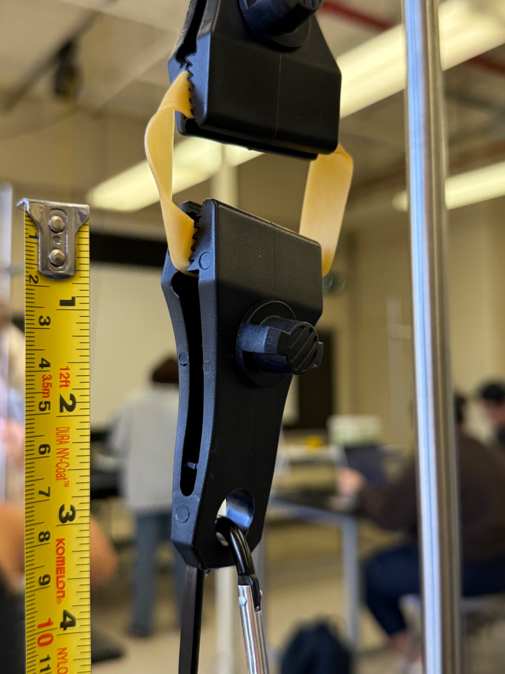
The above image is our setup for measuring the displacement.
The test setup involves two clamps that hold onto the object being tested, with one clamp connecting to a horizontal stabilizer bar, and the second clamp letting us attach various weights to the object to simulate additional forces.

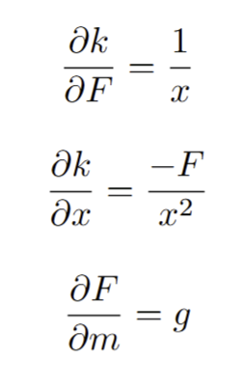
We also note that $F=-kx$.

We will be measuring the displacement of the object across multiple masses, and then compute the K-values for each test, and display both graphs. We will also note where we believe linear and non linear regimes exist for the rubber band.

Our approach is functionally identical to the group in front of us.

Data
Our mass uncertainty is 0.01g, and our displacement uncertainty is 1mm. (0.001m) Consequently, our Force uncertainty is also 0.01N. We converted to SI units inside the calculations for error.

Mass | Force | Displacement | Computed-K | K-Error
50g | .49N | 4 mm | 122.5 | 30.73
100g | .981N | 6 mm | 163.5 | 27.3
200g | 1.962N | 10 mm | 196.2 | 19.65
500g | 4.905N | 22 mm | 222.95 | 10.144
1000g | 9.81N | 50 mm | 196.2 | 3.929

For computing our K-value error, we are ignoring error propagation due to gravity/force, as we believe it to be small enough to be negligible.
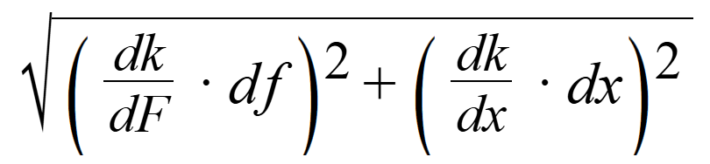
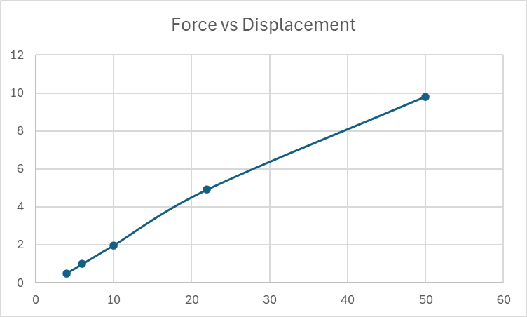
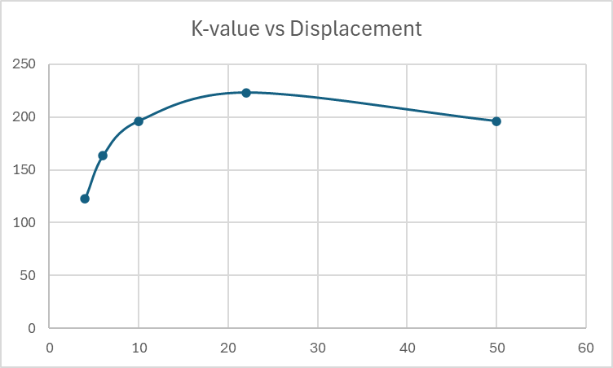

Conclusion
We have a decent amount of error in the K-values which drop off quickly as the masses increase (for example, 30.73 -> 4). We believe that this is primarily due to the lack of precision in measuring displacement, and the setup we used for gathering data in the lab.

Our force-displacement graph appeared to be pretty linear, which we thought was a good sign. The calculated slope on our force-displacement graph was ~202 for a K-value. Our computed K values are somewhat around this value, but we have a pretty wide spread overall.

Our K-displacement graph did not look very nice (as seen above), but we believe the error propagation from measurement devices and the way we tested displacement (see the setup image) contributed heavily to this. Online resources and papers highlight a similar shaped curve for rubber bands / other rubber-esque materials, so we don’t believe we are wildly incorrect.

However, since our force-displacement graph was very linear, we believe that Hooke’s Law applies (mostly) to the entire range of displacements we tested on the rubber band (4mm up to 50mm).

Part 2
Method
Due to our findings in Part 1, we decided to test a different material, a latex balloon. Our method and error calculations will remain the same, but, this time, we will also use T-scores to check Force-Displacement compared to our computed K-values. We mimicked the setup from Part 1, instead replacing the rubber band with a latex balloon.

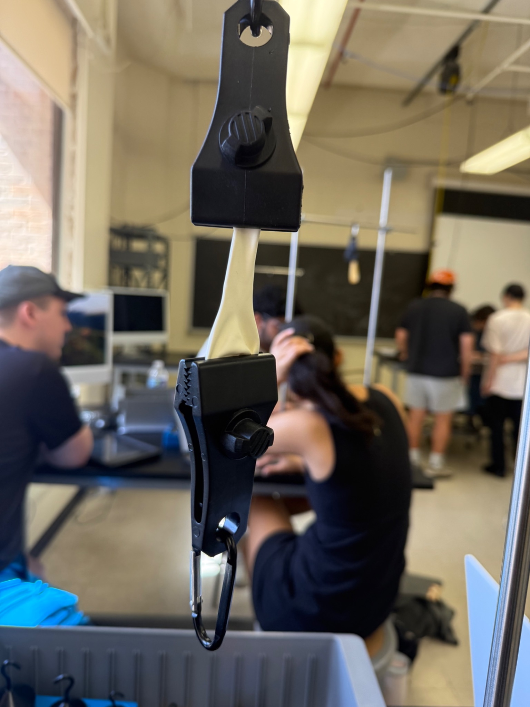

Data
Our mass uncertainty is 0.01g, and our displacement uncertainty is 1mm. (0.001m) Consequently, our Force uncertainty is also 0.01N. We converted to SI units inside the calculations for error. We did not do a 1kg test because the balloon was going to break :)
Our T-scores were computed between the computed K value and the best-estimate value from the Force-Displacement graph seen below.
Mass | Force | Displacement | Computed-K | K-Error | T-scores | Distinguishability
50g | .49N | 3mm | 163 | 54 | 0.497 | Indistinguishable
100g | .981N | 5mm | 196.2 | 39.29 | 2.043 | Inconclusive
200g | 1.962N | 17mm | 115 | 6 | 4.358 | Distinguishable
300g | 2.943N | 34mm | 86.56 | 2.56 | 10.034 | Distinguishable
500g | 4.905N | 82mm | 59.82 | 0.74 | 1.910 | Inconclusive

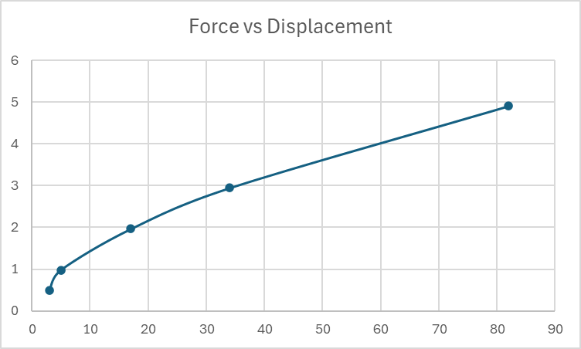
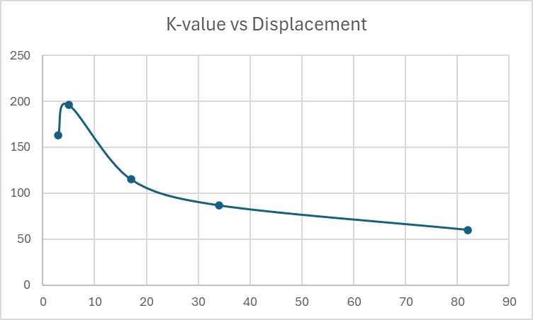
Our force-displacement graph is non-linear; it almost looks logarithmic.

Conclusion
Our graphs are different! Both graphs are very much non-linear, but this isn’t necessarily a bad thing. We predict that our graphs look like this due to (again) measurement error, but also primarily due to the physical properties of latex as the material we were testing. From our force-displacement graph, as the masses increased, the displacement grew at a higher and higher rate. We can see from the T-scores that the distinguishability of latex is difficult to interpret; however, we believe this to be due to the non-linearity of the latex, and loss of precision due to uncontrollable environmental variable(s) and selection of measurement tool(s). Therefore, we were expecting the balloon to be more linear like the rubber band was.

Given the nature of latex, however, it does make sense that there exist nonlinear regimes in displacement of the material. We still believe Hooke’s Law applies, however, with caveats due to the material.

